**07.05.2021**

**PRESS NOTE**

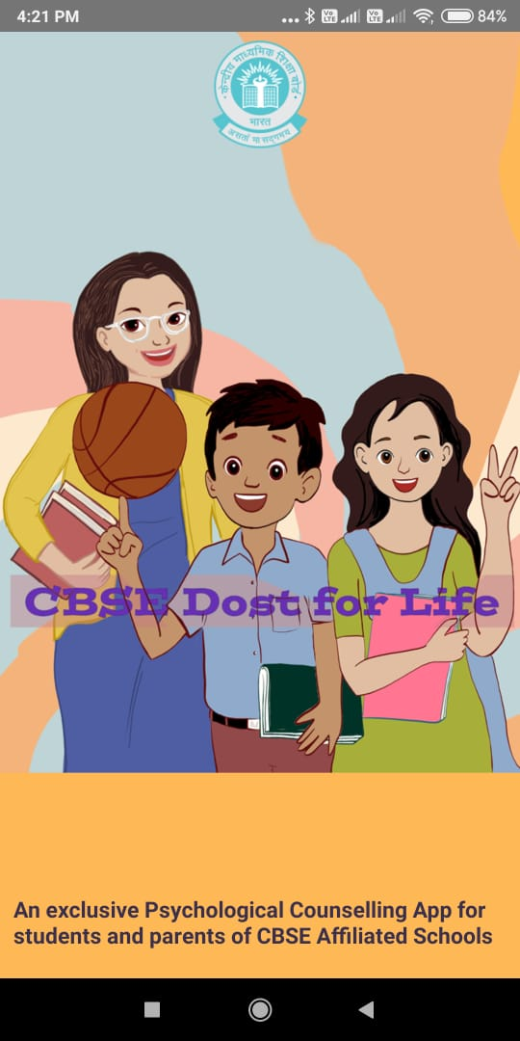

**CBSE Dost For Life: A CBSE initiative for psychosocial well-being of students**

The CBSE annual counselling program this year will make a head start with an all-new feature, a friendly app for students and parents alongside multiple other facilities **from Monday, the 10th of May 2021.**

**In another first CBSE has launched a new app for psycho social Wellness of students** of classes IX-XII during the pandemic. Making a departure from the existing practice of counselling through toll free number across the country, board has designed this facility for the ease, convenience and utility of students and parents with in the safe home environment.

The app comes packed with features like:

**Counselling Sessions** – The new App will simultaneously cater to students and parents from CBSE affiliated schools at different geographies across the world. The live counselling sessions will be conducted free of cost, thrice a week on Monday, Wednesday & Friday by the trained counsellors/Principals. This year there are 83 volunteers out of which 66 are in India and 17 located at Saudi Arab, UAE, Nepal, Oman, Kuwait, Japan and USA.

.

**Choose your own time slot and connect with an expert:**

The students and parents can choose any of the two time slots: 9.30 am - 1.30 pm or 1.30 pm - 5.30 pm and connect through a Chat box as per their convenience.

Besides this, the app will also provide students information on:

**Suggestive Course guide after 10+2**

**Tips on Mental Health & Well Being**

**Corona Guide** - (Daily Protocol, Learning from Home, Self-Care, FAQs) and

**Rap songs**

**-2-**

**CBSE Dost For Life** app is available on Google Play store and can be easily downloaded on any Android phone initially. The board will extend this facility for other phone users in due course of time.

**Audio-visual Messages**

CBSE has prepared educative material on social, emotional and behavioural issues such as Exam Anxiety, Internet Addiction Disorder, Depression, Specific Learning Disability, Substance Use Disorder, Aggression and Life Skills to sensitise students and masses. This can be accessed at website cbse.nic.in and YouTube channel of CBSE.

**Weekly Q&A columns in leading newspapers**

CBSE has already provided valuable advice in the month of April through and reached out to millions of students so far .and will continue to do so.

**Mental Health and Well Being Manual**,

The board has also brought out a manual which discusses the interplay of school, family and community for psychosocial well- being of students at different developmental stages. It has dedicated chapters on dealing with the current pandemic and COVID appropriate behaviours. The manual is available at cbse.nic.in.

The blended approach of CBSE counselling program is its USP which continues to remain popular with students and parents alike at the global level for the past 23 years.

**Rama Sharma**

**Head (Media & Public Relations)**

**Enclosed: A snapshot of steps for downloading the app**

1. CBSE Dost For Life app can be downloaded from Google Play Store on any Android phone.

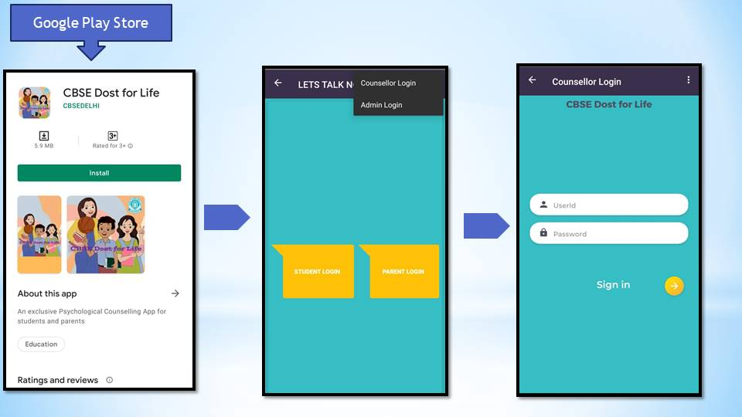

1. Students and parents can login by entering the registered mobile number and registration number of CBSE class IX-XII and
2. Start live counselling via chat box.

